CHAPTER 10- Motion Detection and Video Processing
10.1 Optical Flow
10.2 Object Tracking
10.3 Video Capture and Processing
10.4 Video Generation

10.1 Optical Flow
- Definition: Optical Flow refers to the pattern of apparent motion of objects, surfaces, or edges in a visual scene caused by the relative motion between the observer (camera) and the scene.
- Key Concept: It calculates the movement of pixels between two consecutive frames of a video or sequence of images.
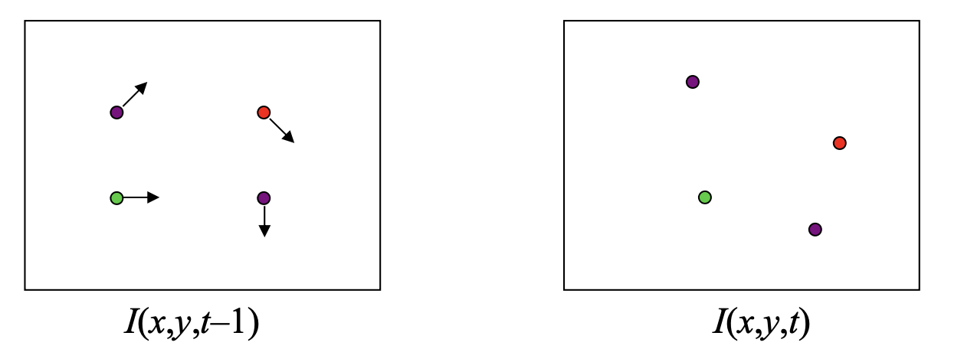

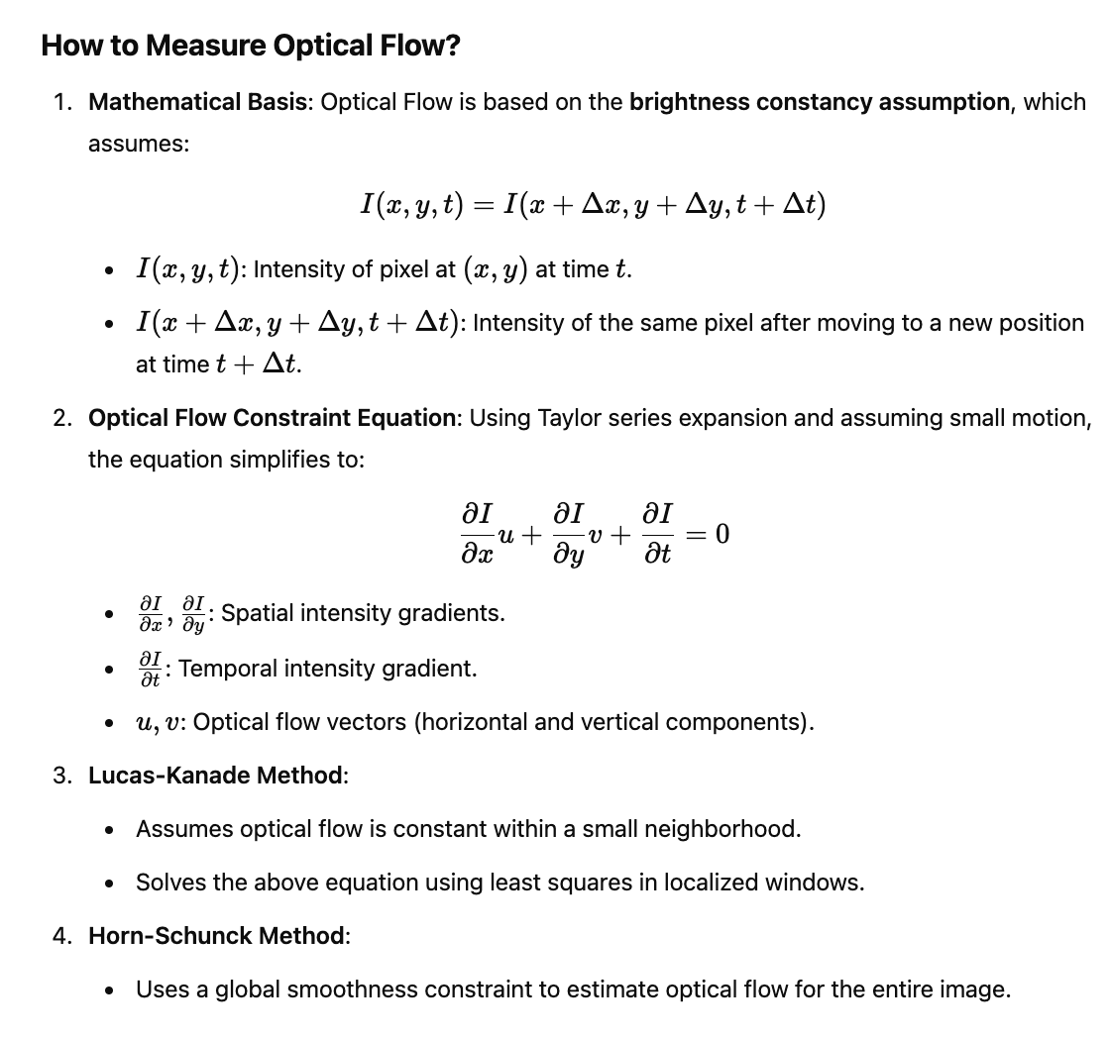
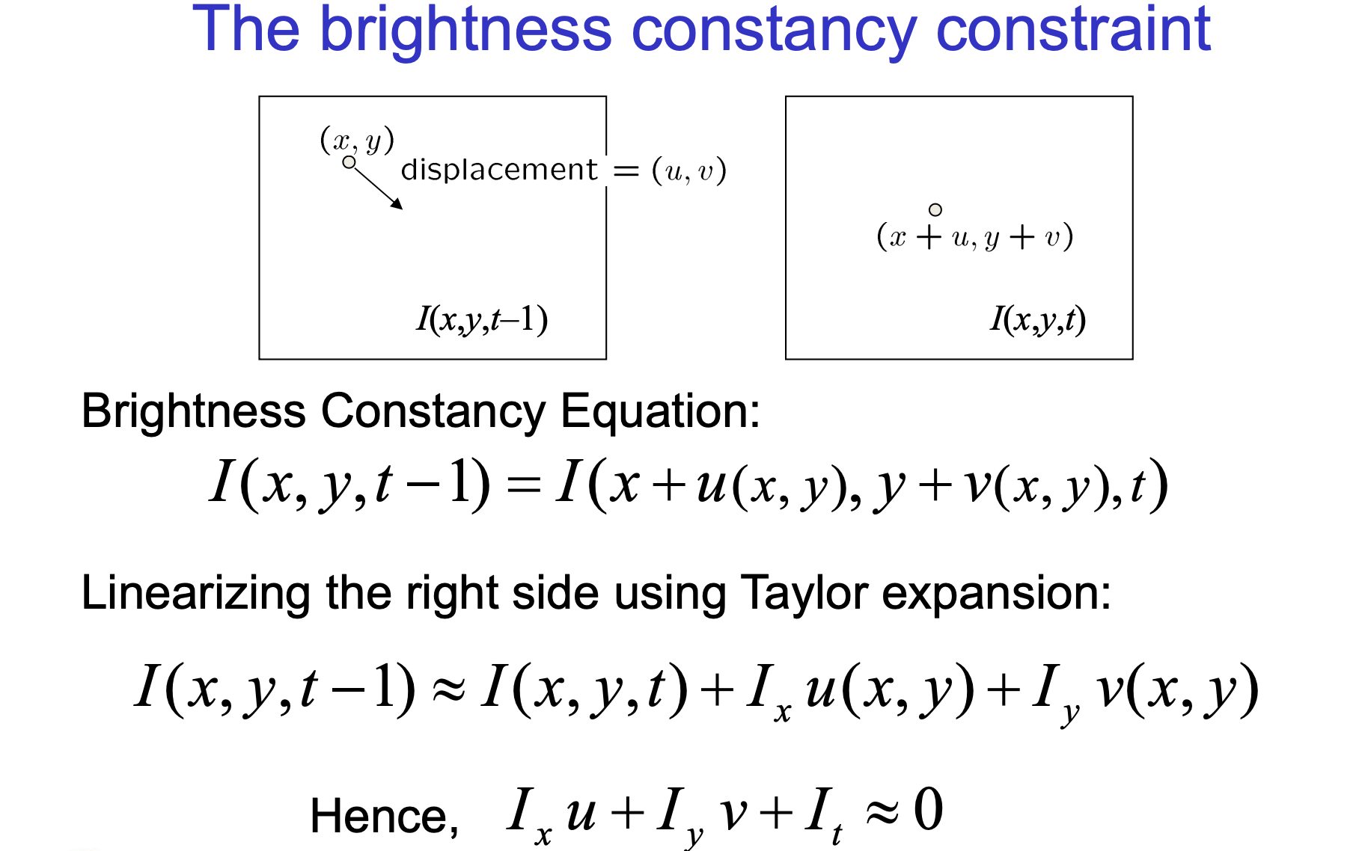
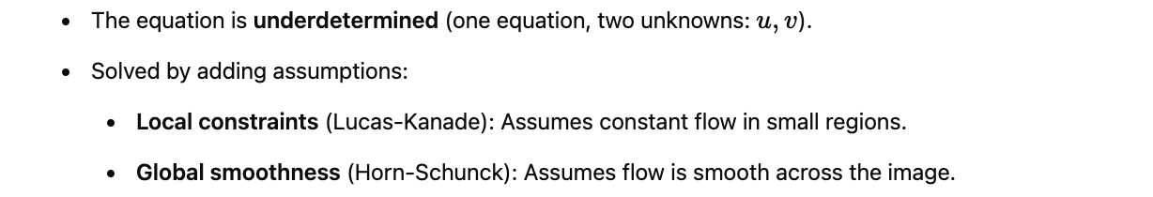

Applications of Optical Flow

Motion Detection:Identifying moving objects in videos.

Example: Autonomous vehicles detecting pedestrians or other vehicles.

Object Tracking:Tracking the movement of specific objects across frames.

Example: Tracking a soccer ball in a match.

Video Compression:Predicting frames in video sequences to reduce redundancy.

Augmented Reality:Understanding motion to overlay AR elements accurately.

Robotics:Used in path planning and obstacle detection.
https://medium.com/thedeephub/object-tracking-and-path-mapping-using-lucas-kanade-optical-flow-in-opencv-2ea018e391d4
https://staff.fnwi.uva.nl/r.vandenboomgaard/IPCV20162017/LectureNotes/CV/Motion/OpticFlow.html

10.1.1 Lucas-Kanade
Lucas Kanade Method is based on something known as Brightness constancy assumption. The key idea here is that pixel level brightness won’t change a lot in just one frame. It assumes that the color of an object does not change significantly and significantly in the previous two frames.
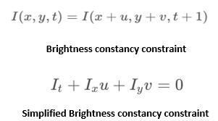
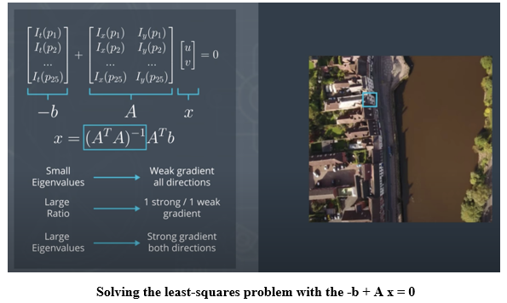
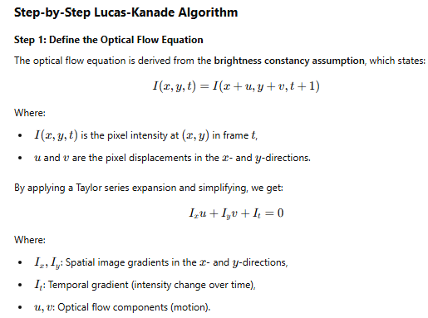
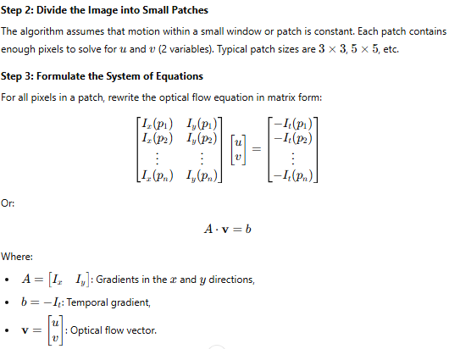
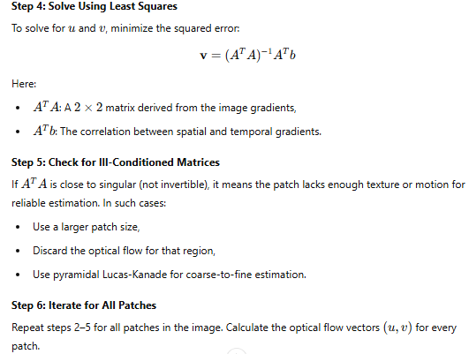

10.1.2: Numerical
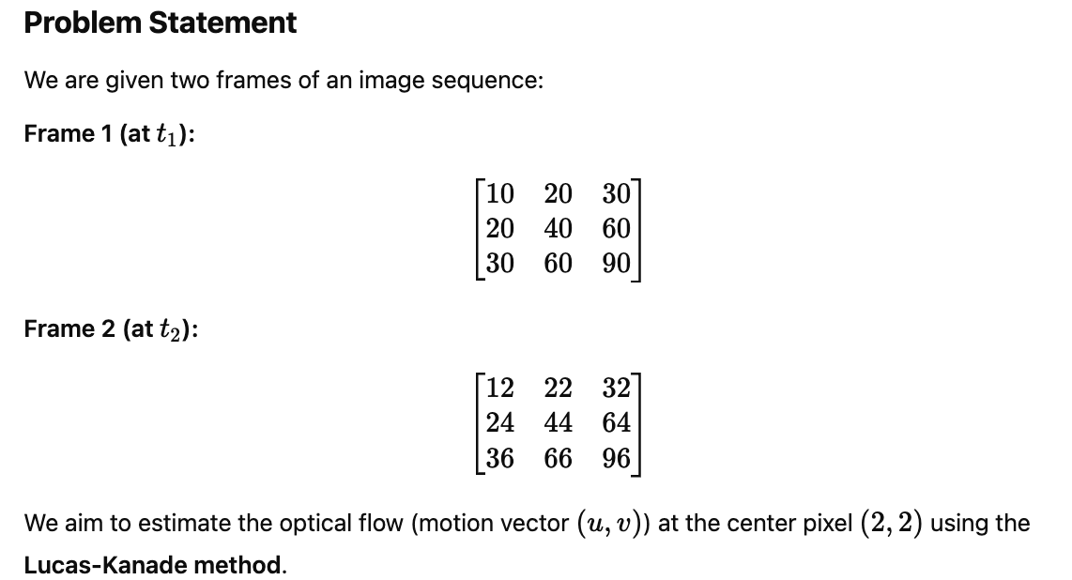
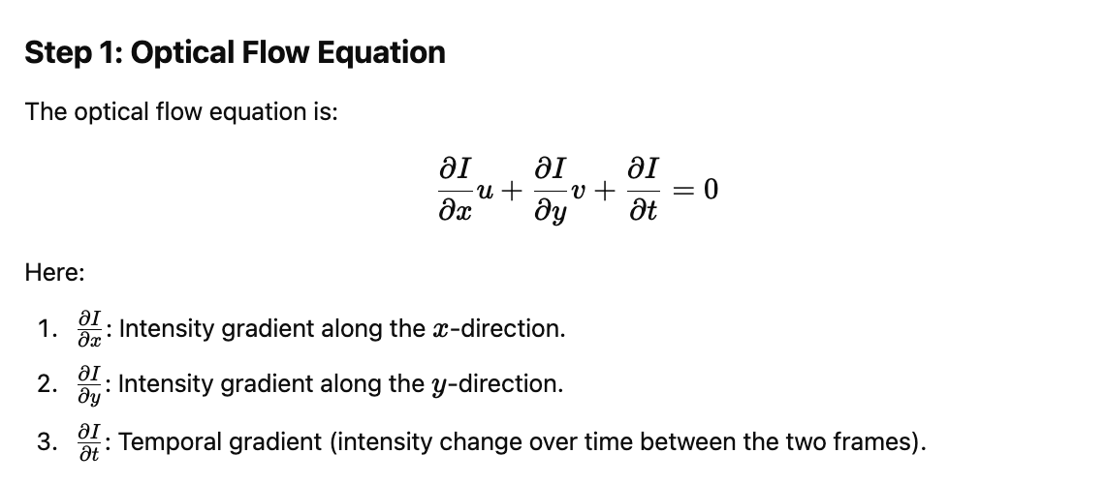
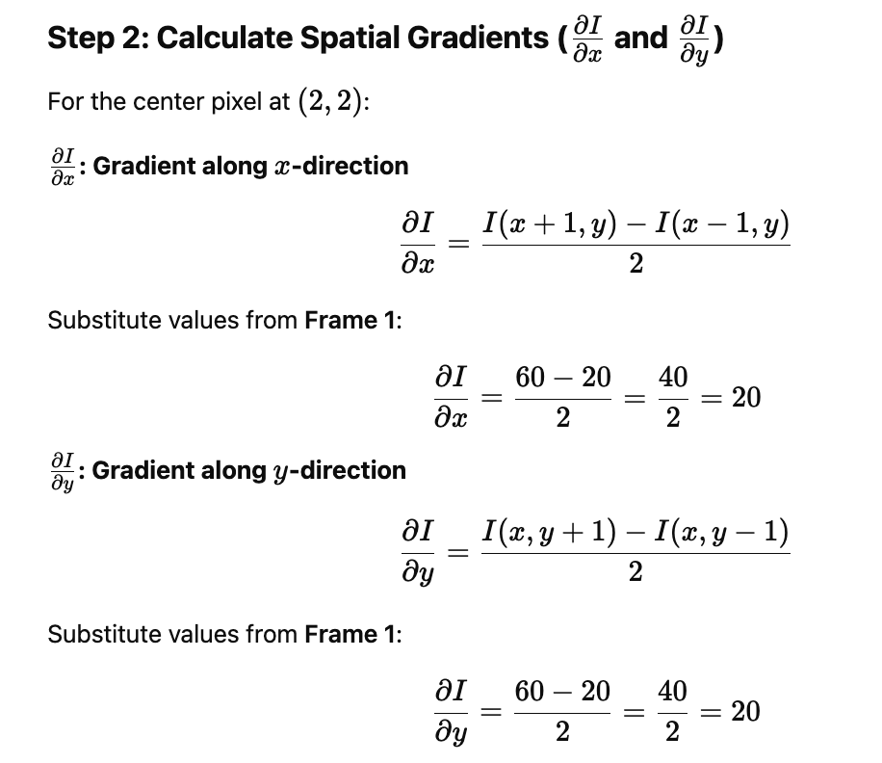
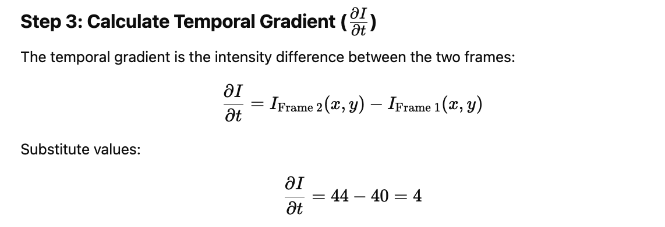
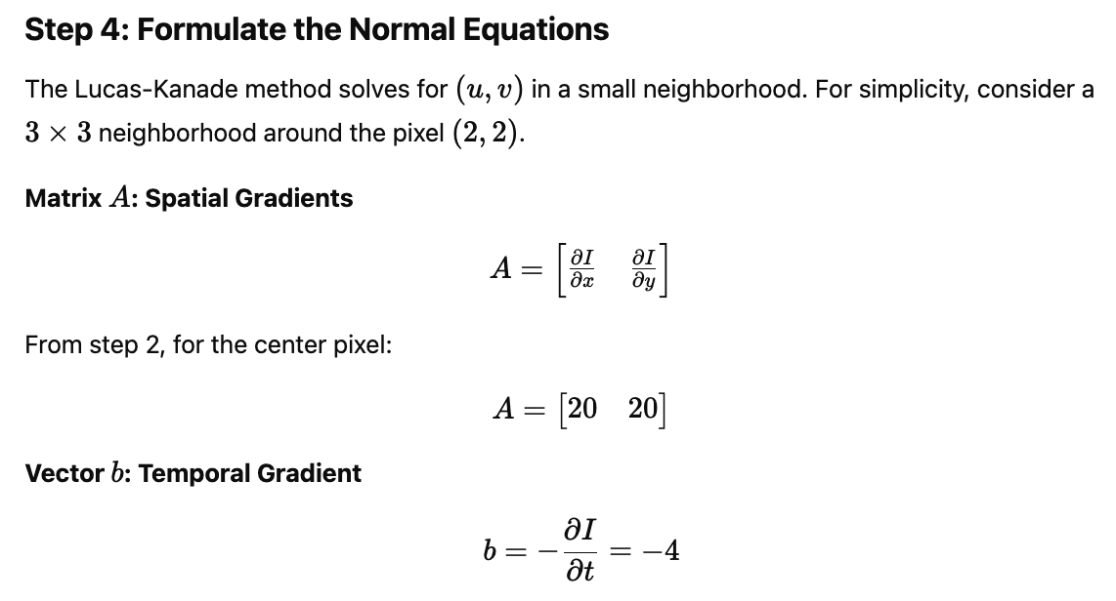
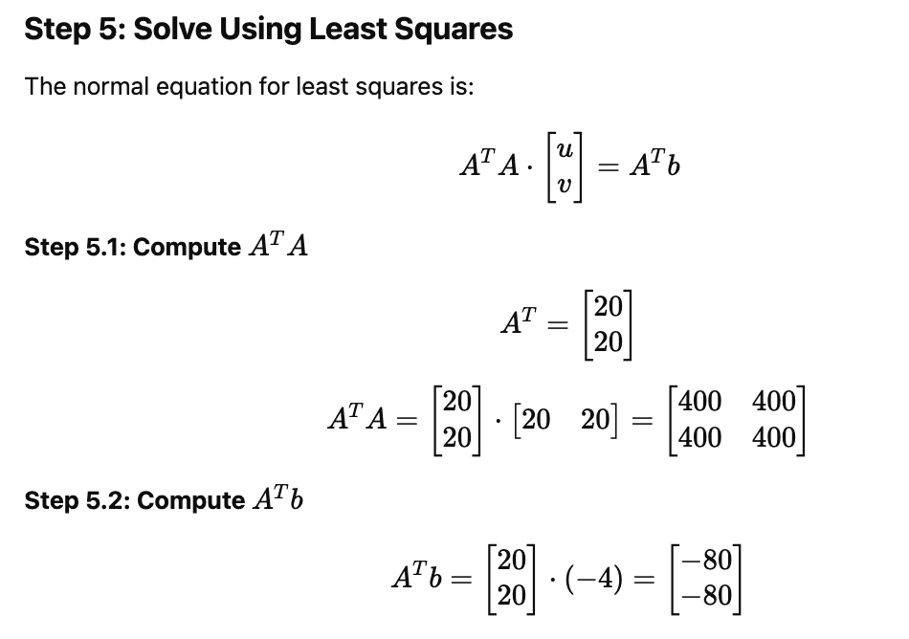
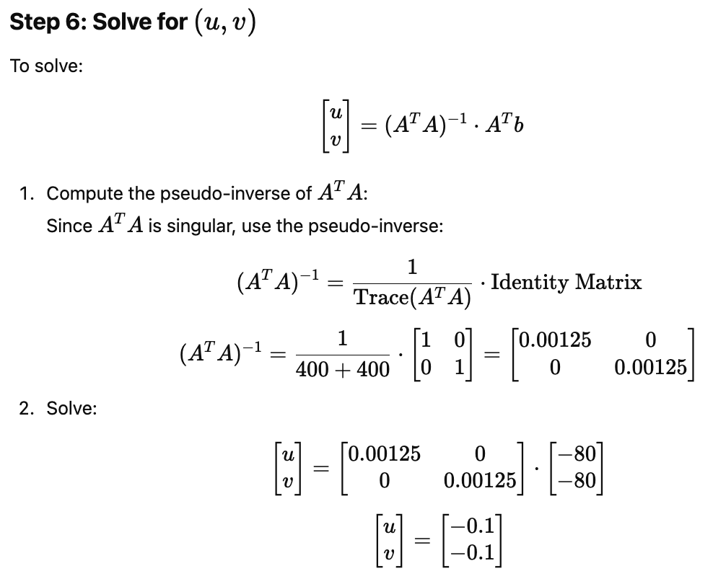
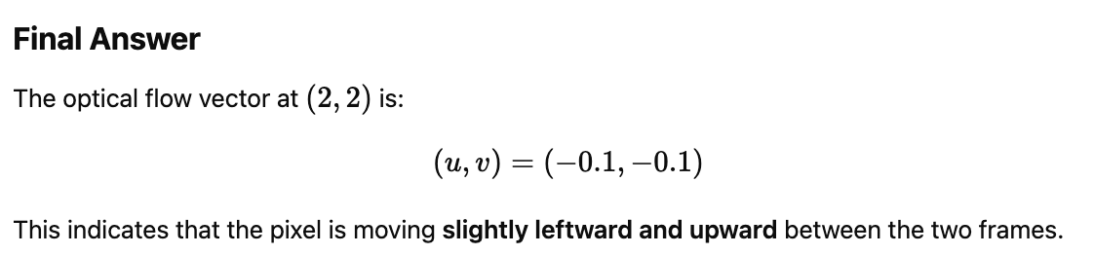
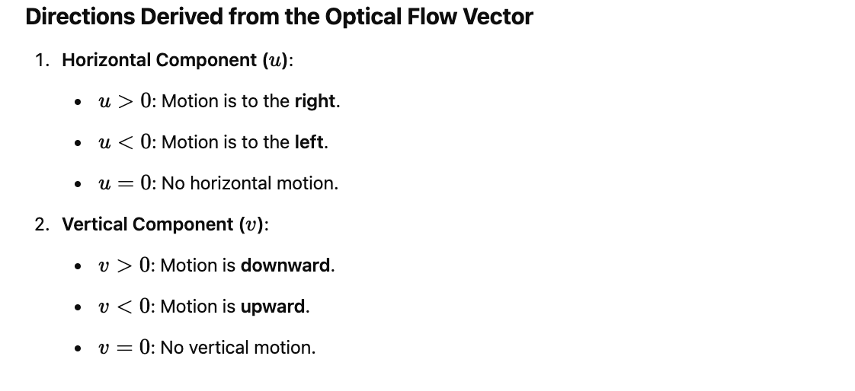
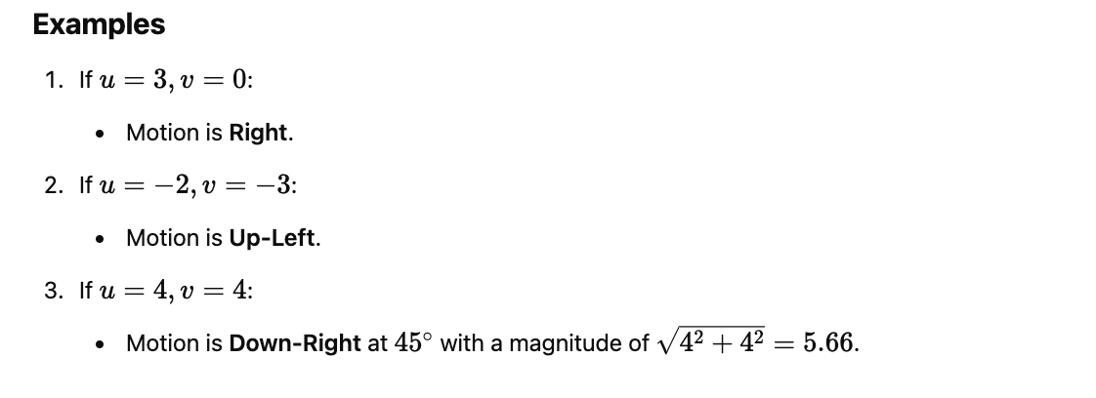

10.1.3 Lucas-Kanade Optical Flow Implementation
The Lucas-Kanade method is used to track points between two video frames.
# 1. Import Required Libraries
import numpy as np
import cv2

# 2. Initialize Video Capture
cap = cv2.VideoCapture('sample.mp4') # Use your video file path or camera source

# 3. Parameters for Corner Detection
feature_params = dict(maxCorners=100,
qualityLevel=0.3,
minDistance=7,
blockSize=7)

# These parameters are used with cv2.goodFeaturesToTrack to detect good corners to track.
# - maxCorners: Maximum number of corners to detect.
# - qualityLevel: Minimum quality of corners (between 0 and 1).
# - minDistance: Minimum distance between detected corners.
# - blockSize: Size of the neighborhood to be used for corner detection.

# 4. Parameters for Lucas-Kanade Method
lk_params = dict(winSize=(15, 15),
maxLevel=2,
criteria=(cv2.TERM_CRITERIA_EPS | cv2.TERM_CRITERIA_COUNT, 10, 0.03))

# Parameters for Lucas-Kanade optical flow:
# - winSize: Size of the search window (15x15 pixels).
# - maxLevel: Maximum number of pyramid levels (2 levels).
# - criteria: Termination criteria for the iterative process.
# - cv2.TERM_CRITERIA_EPS: Stops when specified accuracy is reached.
# - cv2.TERM_CRITERIA_COUNT: Stops after a fixed number of iterations.
# - 10: Maximum number of iterations.
# - 0.03: Accuracy threshold.

# 5. Generate Random Colors for Tracks
color = np.random.randint(0, 255, (100, 3)) # Create an array of random colors for drawing the track

# 6. Capture the First Frame and Detect Initial Points
ret, old_frame = cap.read() # Read the first frame of the video
old_gray = cv2.cvtColor(old_frame, cv2.COLOR_BGR2GRAY) # Convert the first frame to grayscale
p0 = cv2.goodFeaturesToTrack(old_gray, mask=None, **feature_params) # Detect good feature points to track

# 7. Create a Mask for Drawing Tracks
mask = np.zeros_like(old_frame) # Create an empty mask with the same size as the original frame

# 8. Process Each Frame in the Video
while True:
ret, frame = cap.read() # Read the next frame from the video
if not ret: # Break if we have reached the end of the video
break

frame_gray = cv2.cvtColor(frame, cv2.COLOR_BGR2GRAY) # Convert the current frame to grayscale

# Calculate Optical Flow using Lucas-Kanade method
p1, st, err = cv2.calcOpticalFlowPyrLK(old_gray, frame_gray, p0, None, **lk_params)

# p1: New positions of the tracked points.
# st: Status array (1 for successfully tracked points, 0 otherwise).
# err: Error for each point.

# Filter Good Points (where tracking was successful)
good_new = p1[st == 1]
good_old = p0[st == 1]

# -------------FROM HERE NOT IN EXAM (Visualization)----------------------------

# 9. Visualize the Motion
# For every tracked point, draw a line and a circle to show its path:
for i, (new, old) in enumerate(zip(good_new, good_old)):
a, b = new.ravel() # New point coordinates (a, b)
c, d = old.ravel() # Old point coordinates (c, d)
mask = cv2.line(mask, (a, b), (c, d), color[i].tolist(), 2) # Draw a line from old to new position
frame = cv2.circle(frame, (a, b), 5, color[i].tolist(), -1) # Draw a circle at the new position

# Combine the frame and the mask to show the tracks:
img = cv2.add(frame, mask) # Overlay the tracks on the current frame
cv2.imshow('frame', img) # Display the current frame with the tracked points

# 10. Update for the Next Iteration
old_gray = frame_gray.copy() # Update the old frame to the current frame
p0 = good_new.reshape(-1, 1, 2) # Update the points for the next iteration

k = cv2.waitKey(25) # Wait for 25ms between frames
if k == 27: # Press "Esc" to exit
break

# 11. Release Resources and Close Windows
cv2.destroyAllWindows() # Close all OpenCV windows
cap.release() # Release the video capture object
https://www.geeksforgeeks.org/python-opencv-optical-flow-with-lucas-kanade-method/?ref=ml_lbp

10.2 Object Tracking
https://www.v7labs.com/blog/object-tracking-guide
https://medium.com/@khwabkalra1/object-tracking-2fe4127e58bf
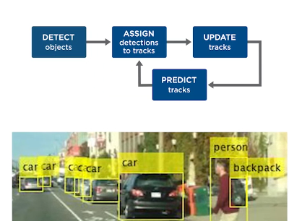

What is Kalman Filter?
The Kalman Filter is an optimal estimation algorithm used in robotics, computer vision, and control systems to predict and correct states of dynamic systems in the presence of noise. It is widely used for object tracking, sensor fusion, localization, and navigation in robotics.
The Kalman Filter (KF) is a recursive algorithm that estimates the state of a dynamic system from a series of noisy measurements. It is particularly useful when the system model and measurement model contain Gaussian noise.
The filter operates in two steps:
- Prediction: Estimate the system’s next state based on the previous state.
- Update (Correction): Adjust the estimate using new sensor measurements.
The Kalman Filter is optimal when the system dynamics and noise follow a linear Gaussian distribution.

2. Why Use a Kalman Filter?
- Reduces measurement noise: It provides a more accurate estimate of the true state.
- Handles missing or noisy data: It can predict future states even when some data points are missing.
- Computationally efficient: Uses a recursive approach, making it suitable for real-time applications.

https://www.scaler.com/topics/kalman-filter-in-computer-vision/
https://medium.com/@siromermer/predicting-objects-motion-with-kalman-filter-and-fast-algorithm-2278c551670b

Kalman Filter Algorithm for Object Tracking in Computer Vision
The Kalman filter is widely used in computer vision to track moving objects like cars, people, or drones. Here’s a simple, step-by-step explanation:
It predicts the next position of an object based on its current state (e.g., position and velocity) and corrects this prediction using noisy measurements (e.g., camera data).
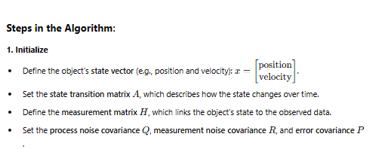
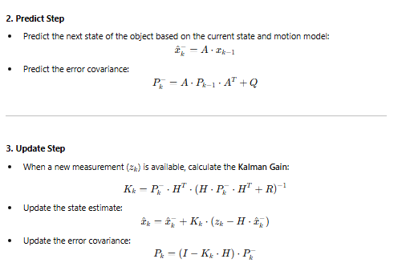

4. Repeat
- Repeat the predict and update steps for each new time step or measurement.
Key Aspects of Kalman Filter
- State Space Model: The Kalman filter models the system as a set of mathematical equations that describe the system's state, the measurements, and the noise in the system.
- Prediction Step: The Kalman filter in computer vision predicts the future state of the system based on the previous state and the system's mathematical model.
- Correction Step: The Kalman filter corrects the predicted state using the measurements obtained from the system.
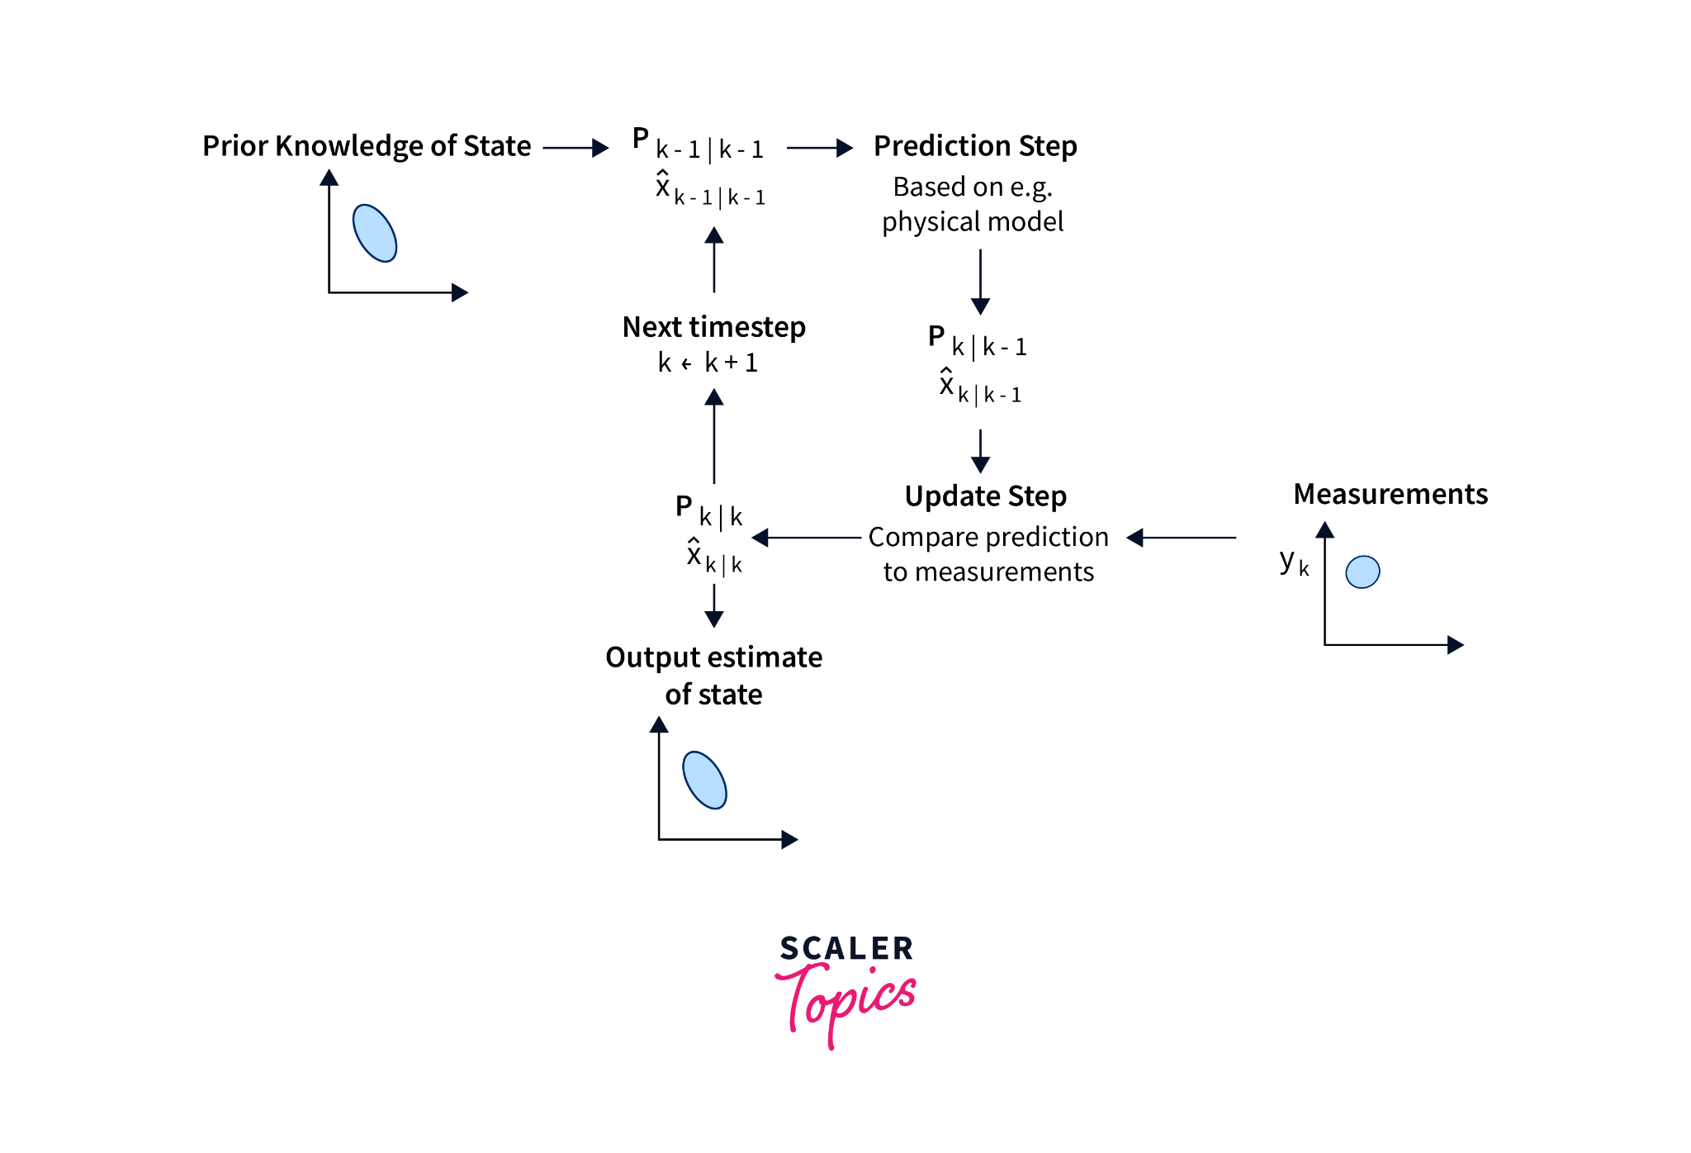

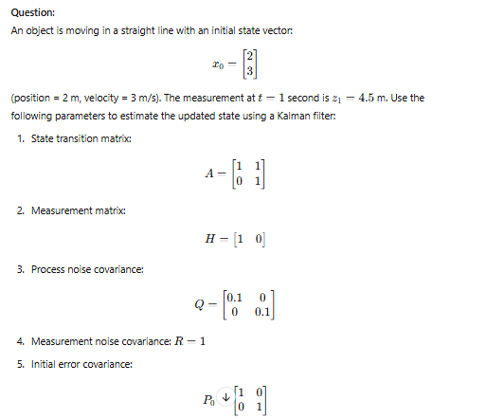
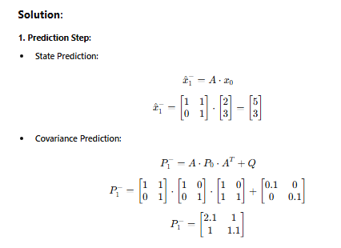
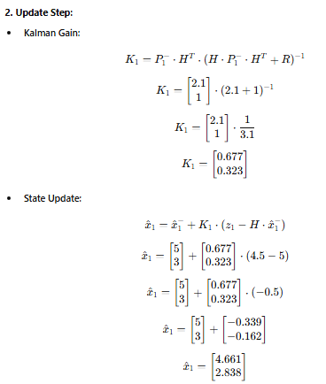
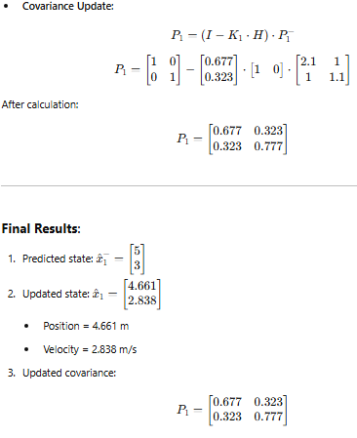
Try yourself:
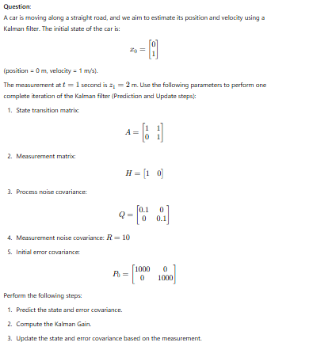
Ans:
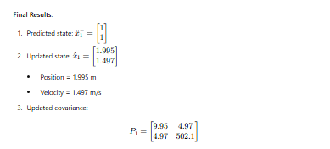
P₁=[10.0005 5
4.95 502.6]

OpenCV functions for Kalman Filter
These functions are part of the cv::KalmanFilter class in OpenCV and can be used to implement the Kalman filter for various applications in computer vision and robotics.
Function | Description
cv::KalmanFilter::KalmanFilter(int dynamParams, int measureParams, int controlParams=0, int type=CV_32F) | Creates an instance of the Kalman filter class with the specified number of state, measurement, and control variables.
cv::KalmanFilter::init(cv::Mat state, cv::Mat cov, cv::Mat &mean) | Initializes the Kalman filter with the initial state and covariance matrix.
cv::KalmanFilter::predict(cv::Mat &control=cv::Mat()) | Predicts the state of the system based on the previous state and the system's mathematical model.
cv::KalmanFilter::correct(cv::Mat measurement) | Corrects the predicted state using the measurements obtained from the system.
cv::setIdentity(cv::Mat &mat, const cv::Scalar &s) | Sets the identity matrix for the specified matrix.
cv::randn(cv::Mat &mat, cv::Scalar mean, cv::Scalar stddev) | Generates a matrix of random numbers with a normal distribution.

CODE:

import cv2

import numpy as np

import matplotlib.pyplot as plt

from google.colab.patches import cv2_imshow

# Upload the video file manually before running this

video_path = "/content/video.mp4" # Change this to your uploaded video file

# Initialize Kalman Filter

kalman = cv2.KalmanFilter(4, 2) # 4 states (x, y, vx, vy), 2 measurements (x, y)

kalman.measurementMatrix = np.array([[1, 0, 0, 0], [0, 1, 0, 0]], np.float32)

kalman.transitionMatrix = np.array([[1, 0, 1, 0], [0, 1, 0, 1], [0, 0, 1, 0], [0, 0, 0, 1]], np.float32)

kalman.processNoiseCov = np.eye(4, dtype=np.float32) * 0.03

# Open Video File

cap = cv2.VideoCapture(video_path)

frame_list = [] # To store frames for later display

while cap.isOpened():

ret, frame = cap.read()

if not ret:

break

# Convert to HSV and detect a colored object (e.g., red object)

hsv = cv2.cvtColor(frame, cv2.COLOR_BGR2HSV)

mask = cv2.inRange(hsv, (0, 100, 100), (10, 255, 255)) # Adjust HSV range for object

# Find object contour

contours, _ = cv2.findContours(mask, cv2.RETR_EXTERNAL, cv2.CHAIN_APPROX_SIMPLE)

if contours:

largest_contour = max(contours, key=cv2.contourArea)

x, y, w, h = cv2.boundingRect(largest_contour)

center = np.array([[np.float32(x + w // 2)], [np.float32(y + h // 2)]])

# Kalman Correction (Update with measurement)

kalman.correct(center)

# Draw detected object

cv2.rectangle(frame, (x, y), (x + w, y + h), (0, 255, 0), 2)

# Kalman Prediction (Predict next position)

predicted = kalman.predict()

predicted_x, predicted_y = int(predicted[0]), int(predicted[1])

# Draw Kalman prediction

cv2.circle(frame, (predicted_x, predicted_y), 5, (0, 0, 255), -1)

frame_list.append(frame)

cap.release()

# Save the processed video

output_path = "/content/output_video.avi"

height, width, _ = frame_list[0].shape

out = cv2.VideoWriter(output_path, cv2.VideoWriter_fourcc(*'XVID'), 20, (width, height))

for frame in frame_list:

out.write(frame)

out.release()

print("Processed video saved at:", output_path)

10.3 Video Capture and processing
1. Video Capturing
Definition: Video capturing refers to the process of acquiring video frames from a source, such as a camera (webcam, external camera) or a video file. Each frame is an image that is displayed in sequence to create the illusion of motion.
- Source of Video: Video can be captured from various sources such as webcams, video files, network streams, or camera feeds.
- Frame Rate: The number of frames captured per second is called the frame rate (e.g., 30 FPS, 60 FPS). A higher frame rate provides smoother motion.
- Resolution: The quality of the video is defined by its resolution, which is the width and height of each frame (e.g., 640x480, 1920x1080).
Techniques:
- Webcam Capture: In most applications, video capturing is done via the built-in camera on a laptop or external webcams using libraries like OpenCV.
- Capture from File: Video can also be read from a file format such as .mp4, .avi, etc.

2. Video Processing
Definition: Video processing involves manipulating the captured video frames to extract information, enhance quality, or apply visual effects. The processed frames can then be displayed or saved.
Common Video Processing Techniques:
- Grayscale Conversion: Converts the video from color to black-and-white. This reduces complexity and is often used in object tracking, facial recognition, and other computer vision tasks.
- Smoothing/Blurring: Techniques such as Gaussian Blur are used to remove noise or smooth out the video to enhance visual quality or prepare for further processing (e.g., edge detection).
- Edge Detection: Methods like Canny Edge Detection identify areas of high contrast in the image, which can be useful for detecting boundaries and features in objects.
- Thresholding: Separating objects or regions of interest based on intensity or color to segment the video into meaningful parts.
- Motion Detection: Detects changes between consecutive frames, useful in surveillance and object tracking applications.
- Object Recognition and Tracking: Identifies and tracks objects in the video stream, often done using algorithms like Haar cascades, SIFT, or deep learning models.
Techniques:
- Temporal Processing: Analyzing a sequence of frames to extract dynamic information (e.g., motion detection).
- Spatial Processing: Analyzing individual frames for static information, like image enhancement or edge detection.

3. Video Writing (Saving Processed Video)
Definition: Video writing refers to the process of saving processed video frames to a new video file. It involves encoding the frames into a video format and storing them for later playback or further analysis.
Components of Video Writing:
- Codec: A codec is an algorithm used to compress and decompress video files. Common video codecs include H.264, XVID, and MJPEG. The codec defines how the frames are stored in a file format.
- File Format: The video file is saved in a particular format like .avi, .mp4, or .mov. Different formats may support different codecs and quality settings.
- Frame Rate and Resolution: When writing a video, the frame rate and resolution must match the captured video (or can be adjusted based on requirements).
- VideoWriter Object: In libraries like OpenCV, the cv2.VideoWriter object is used to save processed frames. You need to specify the codec, frame rate, and resolution when initializing it.
Video Writing Process:
- Step 1: Open a VideoWriter object with the desired settings (codec, frame rate, resolution).
- Step 2: For each processed frame, write it to the video file using the write() method.
- Step 3: After processing and saving the frames, release the VideoWriter object to finalize the file.

Example Flow:
- Capture: Video frames are captured from a webcam.
- Process: Each frame is processed (e.g., grayscale conversion, edge detection).
- Display: Processed frames can be displayed on the screen.
- Save: Processed frames are written to a new video file for storage.
CODE:
import cv2

# Open the webcam (use 0 for default camera, or 1 for external camera)
video_capture = cv2.VideoCapture(0)

if not video_capture.isOpened():
print("Error: Could not open video source.")
exit()

# Loop to continuously capture and process frames
while True:
# Capture frame-by-frame
ret, frame = video_capture.read()

if not ret:
print("Error: Could not read frame.")
break

# Step 1: Convert the frame to grayscale
gray_frame = cv2.cvtColor(frame, cv2.COLOR_BGR2GRAY)

# Step 2: Apply Gaussian Blur
blurred_frame = cv2.GaussianBlur(gray_frame, (15, 15), 0)

# Step 3: Apply Edge Detection (Canny)
edges_frame = cv2.Canny(blurred_frame, 50, 150)

# Step 4: Flip the frame horizontally
flipped_frame = cv2.flip(frame, 1)

# Display all processed frames
cv2.imshow('Original Video', frame)
cv2.imshow('Grayscale Video', gray_frame)
cv2.imshow('Blurred Video', blurred_frame)
cv2.imshow('Edges Video', edges_frame)
cv2.imshow('Flipped Video', flipped_frame)

# Exit the loop when 'q' is pressed
if cv2.waitKey(1) & 0xFF == ord('q'):
break

# Release the video capture object and close all OpenCV windows
video_capture.release()
cv2.destroyAllWindows()

10.4 Video Generation
- Video Generation: The process of creating video content from static images.
- Image Sequencing: The process of arranging images in a sequence to create a video.
- Video Encoding: The process of compressing video data to reduce its size and improve playback efficiency.
- OpenCV: A computer vision library that provides a wide range of functions for image and video processing.
Step 1: Import OpenCV and NumPy
import cv2
import numpy as np
Step 3: Create a Video Writer Object
# Create a video writer object
fourcc = cv2.VideoWriter_fourcc(*'mp4v')
fps = 30.0
frame_size = (1280, 720)
out = cv2.VideoWriter('output.mp4', fourcc, fps, frame_size)
Step 4: Write Images to the Video File
img = cv2.imread('image.jpg')
out.write(img)
Step 5: Release the Video Writer Object
out.release()
Step 6: Add Effects to the Video
# Load an image
img = cv2.imread('image.jpg')
# Apply a Gaussian blur to the image
blurred_img = cv2.GaussianBlur(img, (5, 5), 0)
# Write the blurred image to the video file
out.write(blurred_img)
Step 7: Apply Motion to the Images

# Load an image
img = cv2.imread('image.jpg')
# Define a transformation matrix
M = np.float32([[1, 0, 100], [0, 1, 100]])

# Apply the transformation matrix to the image
transformed_img = cv2.warpAffine(img, M, (img.shape[1], img.shape[0]))
# Write the transformed image to the video file
out.write(transformed_img)
………………JUST FOR PRACTICE not in EXAM…………………..
Example 1: Creating a Video from a Sequence of Images

import cv2
import numpy as np

# Create a video writer object
fourcc = cv2.VideoWriter_fourcc(*'mp4v')
fps = 30.0
frame_size = (1280, 720)
out = cv2.VideoWriter('output.mp4', fourcc, fps, frame_size)

# Load a sequence of images
images = [cv2.imread(f'image_{i}.jpg') for i in range(10)]

# Write the images to the video file
for img in images:
out.write(img)

# Release the video writer object
out.release()

Example 2: Adding Effects to a Video

import cv2
import numpy as np

# Create a video writer object
fourcc = cv2.VideoWriter_fourcc(*'mp4v')
fps = 30.0
frame_size = (1280, 720)
out = cv2.VideoWriter('output.mp4', fourcc, fps, frame_size)

# Load a sequence of images
images = [cv2.imread(f'image_{i}.jpg') for i in range(10)]

# Apply a Gaussian blur to each image
blurred_images = [cv2.GaussianBlur(img, (5, 5), 0) for img in images]

# Write the blurred images to the video file
for img in blurred_images:
out.write(img)

# Release the video writer object
out.release()
Example 3: Applying Motion to an Image

import cv2
import numpy as np

# Create a video writer object
fourcc = cv2.VideoWriter_fourcc(*'mp4v')
fps = 30.0
frame_size = (1280, 720)
out = cv2.VideoWriter('output.mp4', fourcc, fps, frame_size)

# Load an image
img = cv2.imread('image.jpg')

# Define a transformation matrix
M = np.float32([[1, 0, 100], [0, 1, 100]])

# Apply the transformation matrix to the image
transformed_img = cv2.warpAffine(img, M, (img.shape[1], img.shape[0]))

# Write the transformed image to the video file
out.write(transformed_img)

# Release the video writer object
out.release()

